PROGRESS REPORT KELOMPOK 3

HelpDesk

Selasa, 19 Febuari 2019

Anggota :

Muhamad Ilham Habibie

M. Iqbal Aula Rahman

Proggress :

1. Progress hari ini mengerjakan Transaksi masih dalam status on progress untuk L1, L2, dan L3 masih belum fix dan mengerjakan revisi erd yg tambah table subcategory.
2. Login on progress mas.

Modul :

|  |  |  |  |  |  |  |  |
| --- | --- | --- | --- | --- | --- | --- | --- |
| **Nama** | **Modul** | | | | | | |
| **Province** | **Regency** | **District** | **Village** | **Role** | **Religion** | **Quota** |
| Ilham | Done |  |  |  | Done |  | Done |
| Iqbal |  | Done | Done | Done |  | Done |  |
|  |  |  |  |  |  |  |  |
| **Nama** | **Modul** | | | | | |  |
| **Priority** | **Category** | **Ticket** | **Ticket Progress** | **Customer** | **Staff** |  |
| Ilham | Done | Done | On Progress | On Progress | Done | Done |  |
| Iqbal |  |  |  |  | Done | Done |  |

1. ERD

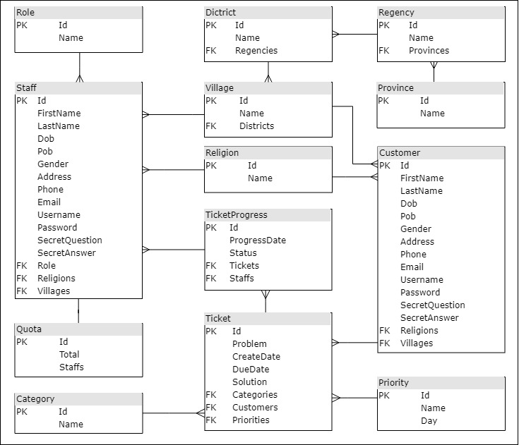

1. Use Case Diagram

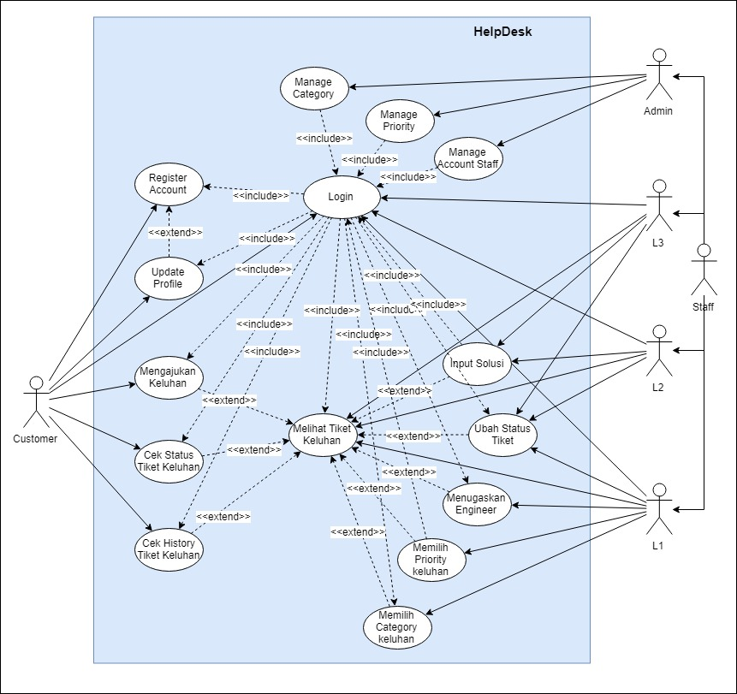

1. Class Diagram

